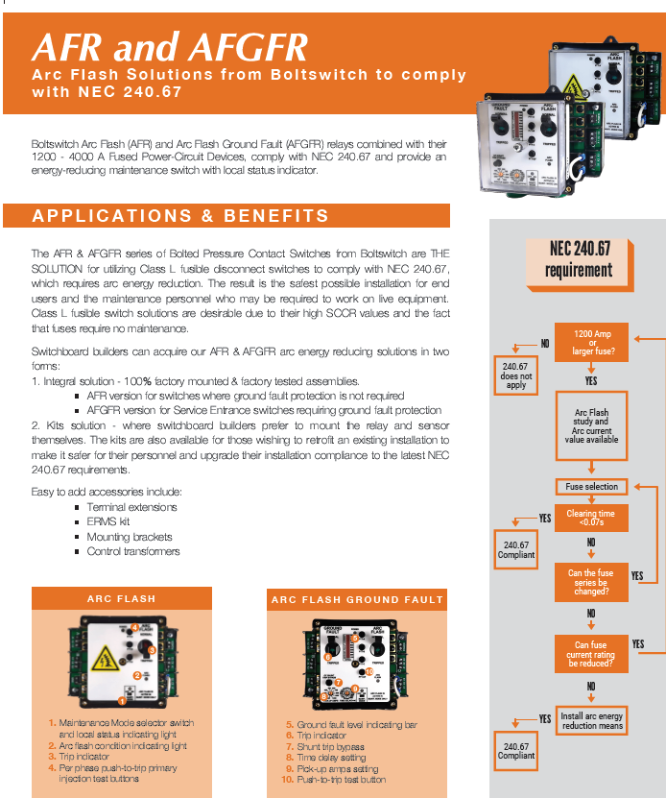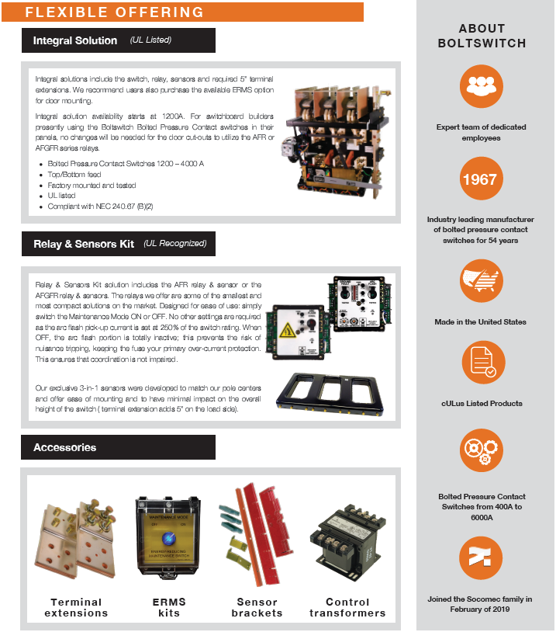
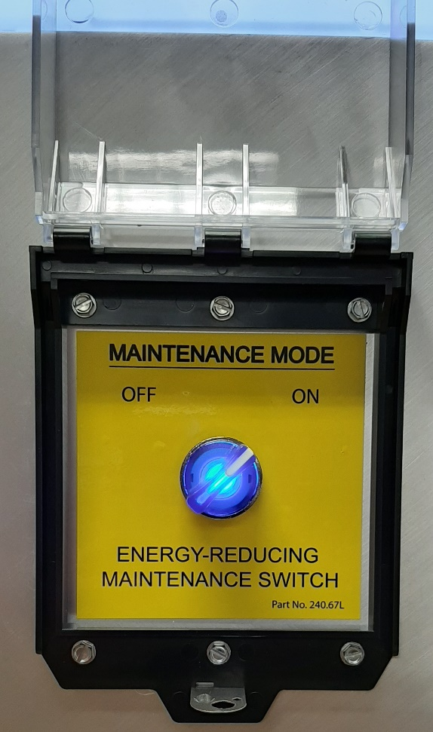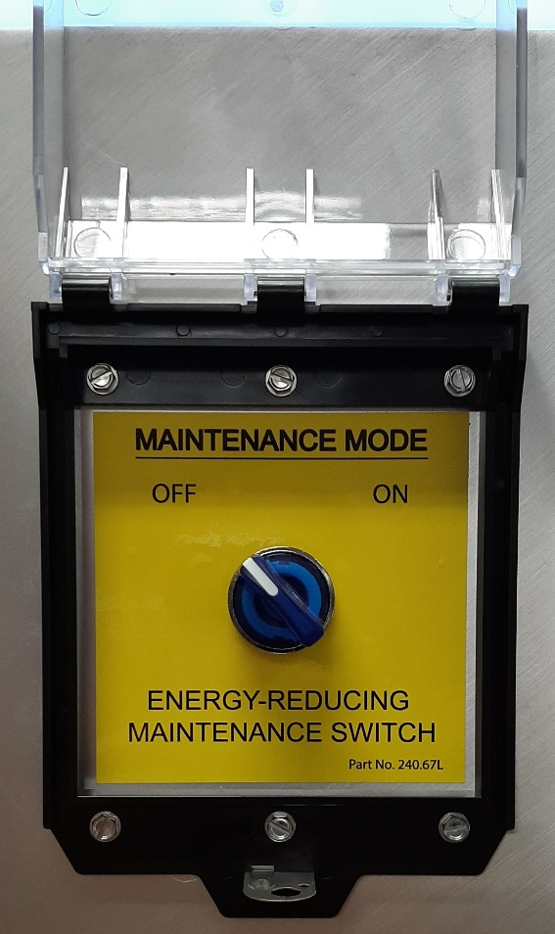

The above pictures (activated/deactivated) illustrate the optional maintenance switch. The maintenance switch reduces the arc flash incident energy downstream at equipment that is protected by the switch/fuse combination. In effect, the maintenance switch controls the arc flash (see page #4) relay to reduce the tripping time during an arc flash event within the branch/feeder circuit fed by the fuse/switch combination.

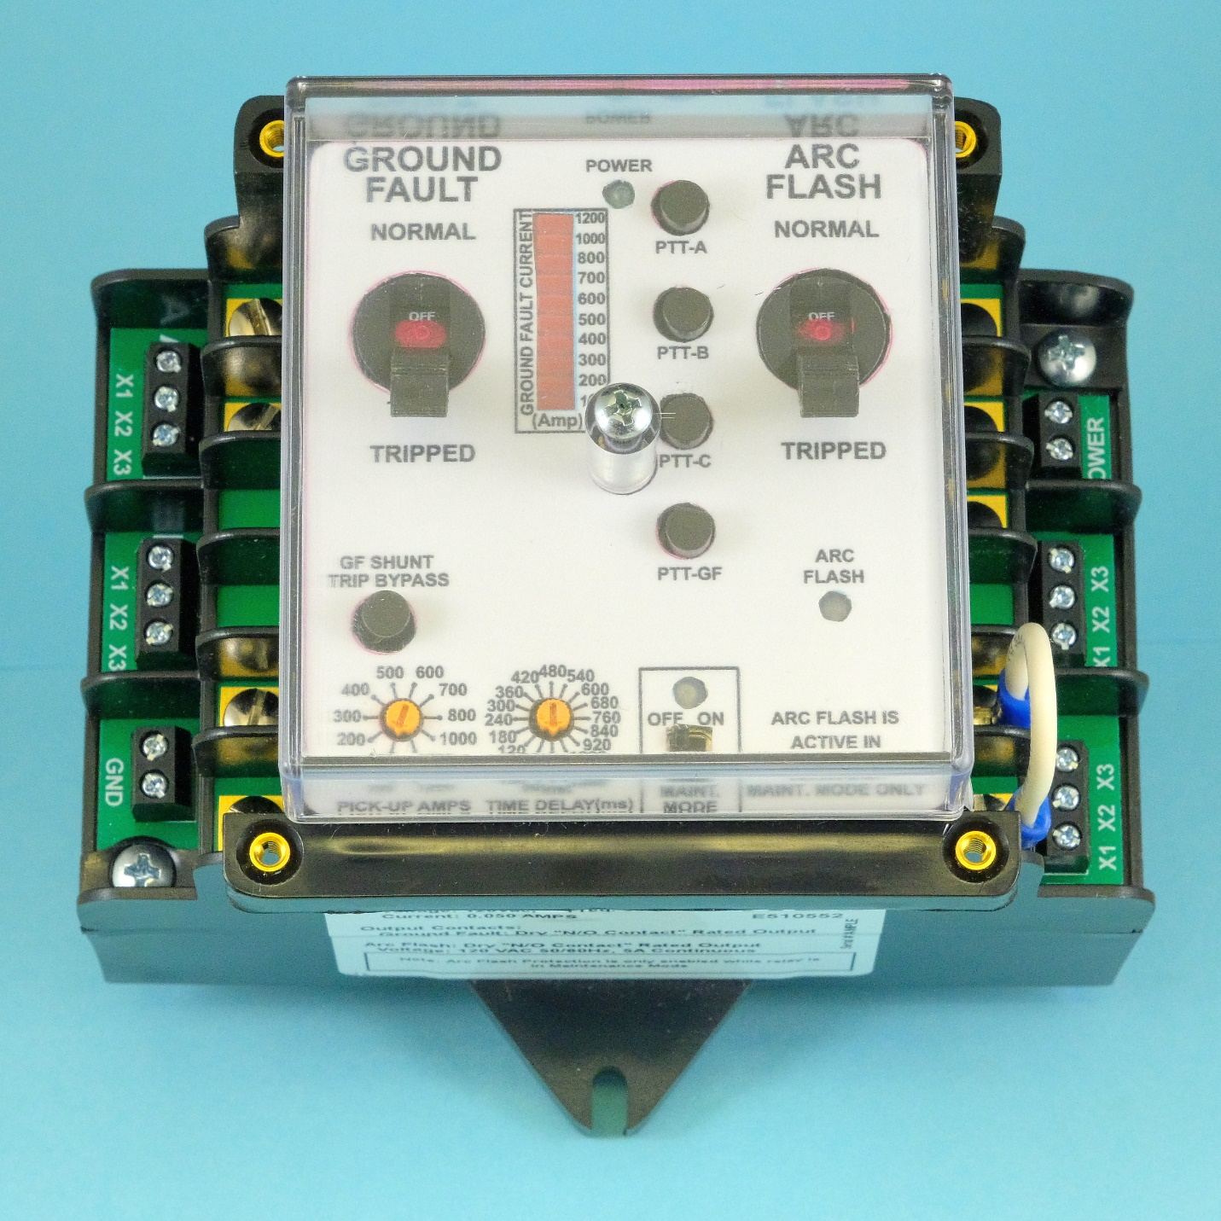

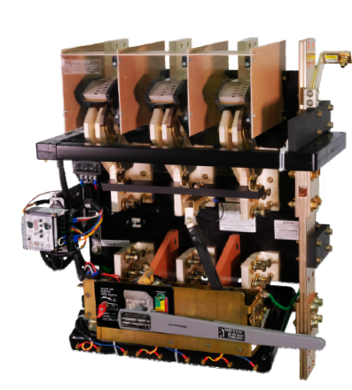
The Red circle above denote the location of the arc flash relay

The table below are the approximate costs to add the complete Energy Reduction system
Part Number | Description | Cost
AD8CO | Arc Flash Kit | 1,810.00
TE10 | Bus Extension | 80.00
VLMS | Relay mounting bracket top feed | 90.00
CPT480 | Control transformer | 80.00
RSCK1 | ERMS switch | 110.00

IMPORTANT - The correct part numbers will depend on the the switch ampacity and physical configuration.

NEC Section 240.67 (2020)
240.67 Arc Energy Reduction. Where fuses rated 1200 A or higher are installed, 240.67(A) and (B) shall apply. This requirement shall become effective January 1, 2020.
(A) Documentation. Documentation shall be available to those authorized to design, install, operate, or inspect the installation as to the location of the fuses. Documentation shall also be provided to demonstrate that the method chosen to reduce clearing time is set to operate at a value below the available arcing current.
(B) Method to Reduce Clearing Time. A fuse shall have a clearing time of 0.07 seconds or less at the available arcing current, or one of the following means shall be provided and shall be set to operate at less than the available arcing current:
(1) Differential relaying
(2) Energy-reducing maintenance switching with local status indicator
(3) Energy-reducing active arc-flash mitigation system (4) Current-limiting, electronically actuated fuses
(5) An approved equivalent means
Informational Note No.1: An energy-reducing maintenance switch allows a worker to set a disconnect switch to reduce the clearing time while the worker is working within an arc-flash boundary as defined in NFPA 70E-2018, Standard for Electrical Safety in the Workplace, and then to set the disconnect switch back to a normal setting after the potentially hazardous work is complete.

Example of the Reduced Incident energy with the Erms activated
When protected by Mersen A4BQ1200 Class L current-limiting fuses and/or the integral boltSwitch energy reduction relay, the incident energy values in cal/sqcm are as follows:
Bolted Fault Current | Fuse Type | Incident Energy Without Energy Reduction Relay (cal/sq cm) | Incident Energy With Energy Reduction Relay (cal/sq cm)
10,000 | Mersen A4BQ1200 | 59.7 | 3.7
15,000 | Mersen A4BQ1200 | 9.0 | 6.1
20,000 | Mersen A4BQ1200 | 1.6 | same
30,000 | Mersen A4BQ1200 | 0.8 | same

Note – the incident energy is actually lower than noted in the high fault current cases because the IEEE1584 current-limiting fuse algorithms were not used. The results may also vary due to variations in the actual system.

